|  |  |  |  |  |
| --- | --- | --- | --- | --- |
| Decorative | | | | |
|  |  |  | |  |
| Business Report  YEAR IN REVIEW | | |
| HBFC BANK REPORT | |  |

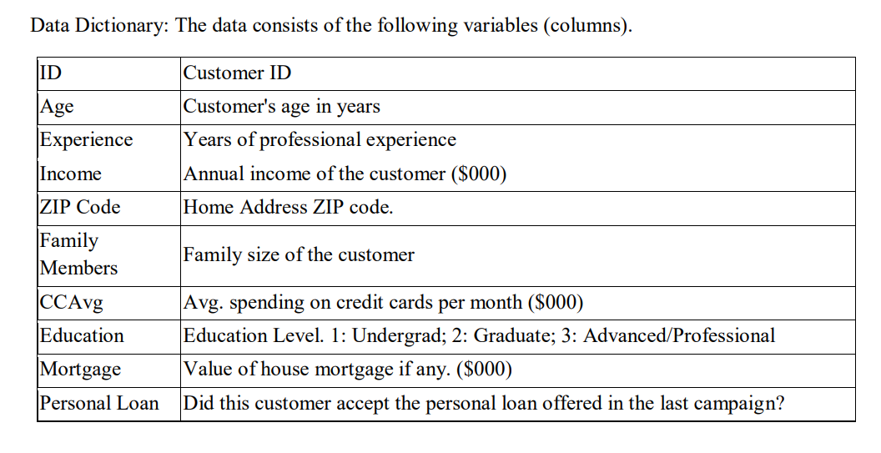

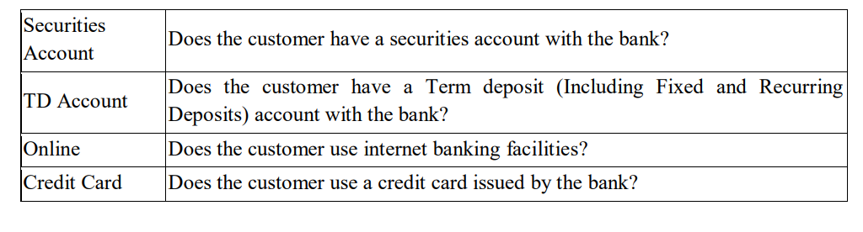

Additionally, a column Income Categorical has already been created for your reference.

Data for reference:  [HBFC Bank-1.xlsx](https://olympus.mygreatlearning.com/courses/103158/files/9501412/download?verifier=RVGublollkdsmJfEZBV1PbM0Bwq9JO9p4FK383Q3&wrap=1)

1. What percentage of the bank’s customers (according to the data) have availed Personal Loans?

|  |  |
| --- | --- |
| **Personal Loan Status** | **Personal loan (%)** |
| No | 90.40% |
| Yes | 9.60% |
| **Grand Total** | **100.00%** |

**This implies that only 9.6 % of the bank's customers have availed personal loan.**

2. Generate a table with min, max, median & average for all numeric variables (age, experience,

income, family members, CC Avg, Mortgage). What are your observations?

|  |  |  |  |  |
| --- | --- | --- | --- | --- |
| **Factors** | **Minimum** | **Maximum** | **Median** | **Average** |
| **AGE** | 23 | 67 | 45 | 45 |
| **EXPERIENCE** | 0 | 43 | 20 | 20 |
| **INCOME** | 8 | 224 | 64 | 73.8 |
| **FAMILY** | 1 | 4 | 2 | 2 |
| **CREDIT CARD AVG** | 0 | 10 | 1.5 | 1.9 |
| **MORTGAGE** | 0 | 635 | 0 | 56.5 |

**OBSERVATIONS:**

* **The customers of HBFC Bank are in the age ranging from 23 years to 67 years.**
* **Bank’s customers have an average Professional experience of 20 years whose average income is 73.8 K / Annum.**
* **The maximum value of house mortgage that a customer has is $ 635.**

3. Create a new categorical variable for Experience using 4 categories – a. 0 to 10 years b. 11 to 20 years c. 21 to 30 years and d. 30+ years. Plot a bar graph for this new categorical variable

|  |  |
| --- | --- |
| **Experience Categorical** | **Count of Experience Categorical** |
| 0-10 | 1289 |
| 11-20 | 1253 |
| 21-30 | 1301 |
| 30+ | 1157 |

**This shows that there are huge number of customers who have 21- 30 of Professional experience compared to other range groups.**

4. Create a scatter plot of the Age and the Experience variable. What do you observe?

**As age increases the experience of the customers also gets increased.**

5. What are the top 3 areas (ZIP Codes) where the bank’s customers are located?

|  |  |
| --- | --- |
| **Zip Code** | **Count of Customers** |
| 94720 | 169 |
| 94305 | 127 |
| 95616 | 116 |

**Therfore, many customers of the bank are located in the highlighted Zip Codes. (**94720,94305,95616)

6. How many customers have a combination of Fixed Deposits and Credit Cards but not Personal Loan?

**Reference Charts:**

|  |  |
| --- | --- |
| **FD** | **Count of TD Account** |
| No | 4698 |
| Yes | 302 |
| **Grand Total** | **5000** |
|  |  |
|  |  |
| **CC** | **Count of Credit Card** |
| No | 3530 |
| Yes | 1470 |
| **Grand Total** | **5000** |
|  |  |
|  |  |
| **PL** | **Count of Personal Loan** |
| No | 4520 |
| Yes | 480 |
| **Grand Total** | **5000** |

Using this formula “=COUNTIFS (HBFC [TD Account],"Yes", HBFC [CreditCard],"Yes", HBFC [Personal

Loan],"No")” the following answer is calculated.

**The number of customers who have combination of Fixed deposit and Credit card but not Personal Loan = 147**

7. What is the median income of the customers who have availed personal loans and compare it with the median income of those customers who have not availed personal loans? What do you infer?

**Median income of the customers who have availed personal loan is 136.5K/year.**

**Median income of the customers who have not availed personal loan is 70.5K /year.**

**The median income of the customers who have availed personal loan is more than that of customers who have not availed personal loan.**

8. Create 4 separate Pivot Tables. Summarize your data by percentages. • Education vs Personal Loan • TD Account Vs Personal Loan

• Online vs Personal Loan

• Income_Category vs Personal Loan

|  |  |  |
| --- | --- | --- |
| **Count of Personal Loan** | **PL** |  |
| **Education** | **No** | **Yes** |
| Graduate | 87.03% | 12.97% |
| Professional | 86.34% | 13.66% |
| Undergraduate | 95.56% | 4.44% |

**More percentage of Graduates and Professionals have availed Personal Loan than Undergraduates.**

|  |  |  |
| --- | --- | --- |
| **Count of Personal Loan** | **PL** |  |
| **TD** | **No** | **Yes** |
| No | 92.76% | 7.24% |
| Yes | 53.64% | 46.36% |

**The customers who have Fixed deposit in the bank had also availed Personal loan more than the customers who have no FD account.**

|  |  |  |
| --- | --- | --- |
| **Count of Personal Loan** | **PL** |  |
| **Online** | **No** | **Yes** |
| No | 90.63% | 9.38% |
| Yes | 90.25% | 9.75% |

**Only 9-10% of the personal loan customers have Internet banking facility.**

|  |  |  |
| --- | --- | --- |
| **Count of Personal Loan** | **PL** |  |
| **Income ©** | **No** | **Yes** |
| 0-50 | 100.00% | 0.00% |
| 100+ | 63.86% | 36.14% |
| 51-100 | 97.76% | 2.24% |

**The customers whose annual income in the range of 0-50k have never availed Personal loan.**

**The customers who have annual income more than 100k have availed Personal loan in more numbers than other income category groups.**

9. Analyse the Pivot tables created in the previous question and state any anomaly that you observe. Which categorical variables appear most important for your further study if you want to analyse which customers are most likely to take personal loans and why?

1. **All customers who had lower income range (0-50K/year) have availed Personal loan according the data.**
2. **The Income categorical variables are very helpful in analysing and finding the suitable customers to reachout in the near future. After studying the given data, the numbers suggested that the people with less income are more likely ready to take Personal loan than those with higher Income.**

10. In the last campaign, bank reached out to 5000 customers out of which 480 customers accepted the personal loan offer. The bank incurred a huge cost in running a marketing campaign to reach out to so many customers. This is where you as a strategic business consultant step in. You are tasked to optimise the cost of this campaign by identifying the correct target base (without significant reduction in number of acceptances of offers). The bank can then send Personal Loan offers to these target customers who have a higher chance of accepting the offer. Based on your analysis, what strategy would you suggest to the management of HBFC bank?

**With reference to the following data,**

[HBFC Bank-1.xlsx](https://olympus.mygreatlearning.com/courses/103158/files/9501412/download?verifier=RVGublollkdsmJfEZBV1PbM0Bwq9JO9p4FK383Q3&wrap=1)

|  |  |  |
| --- | --- | --- |
| **Experience Vs PL** | **PL** |  |
| **Experience** | **No** | **Yes** |
| 0-10 | 25.58% | 27.71% |
| 11-20 | 25.11% | 24.58% |
| 21-30 | 26.15% | 24.79% |
| 30+ | 23.16% | 22.92% |

**Education Vs Personal Loan**

**Age Vs Personal Loan**

**Income Vs Personal Loan**

**As a strategic business consultant, I would suggest the bank to keep their marketing campaign as simple as possible by finding the suitable target audience and reach out to them particularly in more numbers. By doing so the cost of the campaign can also be minimized and there will be a significant rise in the number of acceptances of loan offer than the last campaign.**

**With reference to data and charts from the last campaign, I believe that nearly 37% of the reached customers who have income more than 100 K per annum had availed personal loan while every customer with less than 50 K per annum had rejected the offer.**

**Moreover, Education plays a vital role in the selection of target audience. According to the data, undergraduates are less interested in personal loan than graduates and professionals. But, a greater number of undergraduates had been reached out during the last campaign.**

**All age groups listed in the reference table were more or less equally interested in personal loan. But when compared the customers who were in the age range of 23-35 are slightly more interested than others.**

**Target Customers:**

1. **Customers who started their professional career.**
2. **Graduates and professionals.**
3. **Customers with income more than 100K / year.**

**Now I would suggest the bank to reach-out to the graduates who recently started their professional career with more than 100K per annum in more numbers.**

**Out of 100 % target customers, this will be the better strategy to get hopeful outcome.**

|  |  |
| --- | --- |
| **Graduates with more than 100K / Annum who recently started their professional career** | **50%** |
| **Professionals who are above 30 years of age with more than 70K / Annum** | **25%** |
| **Qualified undergraduates** | **15%** |
| **Others** | **10%** |

**Thank you**